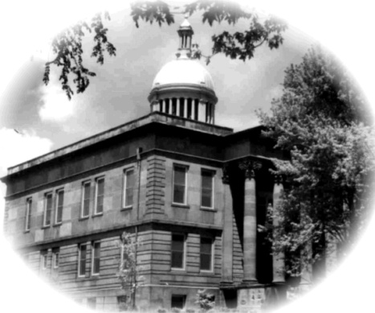
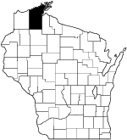

Bayfield County Teen Court Application

Please complete both sides of this application and return by the November 7 deadline.

Name:
Last First M.I.

Mailing Address:
City: Zip Code Phone:

School: e-mail:
Current Grade

How did you hear about the Bayfield County Youth Teen Court ?

Describe why you are interested in serving on the Teen Court and what skills you possess that will help you serve your community as a representative?

What does keeping “An Oath of Confidentiality” mean to you?

Teen Court hearings take place on the 2nd Wednesday of each month at the county courthouse.
Do you have access to reliable transportation to attend each case? Yes No
Does your schedule allow you to make this commitment? Yes No

Describe three characteristics of a positive role model?

1)

2)

3)

What do you hope to achieve through your involvement in Teen Court?

Describe a challenging situation you faced communicating your point of view to another person or a group and what you did to overcome this challenge?

The previous information is true, correct, and complete to the best of my knowledge.

Signature of applicant Date

Please return this completed application to:

Ian Meeker
UW-Extension -Teen Court Advisor
P.O. Box 218
Washburn, WI 54891

Thank you for applying to the Bayfield County Teen Court.
You will be contacted when final selections have been made.

