Dear Bayfield County Teen Court Applicant,

Thank you for your interest in applying for the Bayfield County Teen Court. If you have any questions or concerns please feel free to contact me at my office or by e-mail. I would encourage you to speak to the panelists from your school as well.

The UW-Extension Office phone number is 373-6104 ext 249.

My e-mail address is ian.meeker@ces.uwex.edu

Application Check List:

_____ Contact and distribute two reference forms.

_____ Complete personal application form.

_____ Application must be received by November 7th

Make sure to let your references know the application deadline. If you would like an update to the status of your application please call or e-mail using the contact information above.

Good luck,
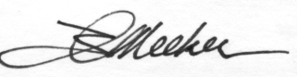

Ian Meeker
4-H & Youth Development Educator
UW-Extension
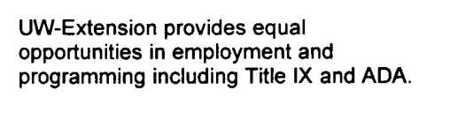
Bayfield County

