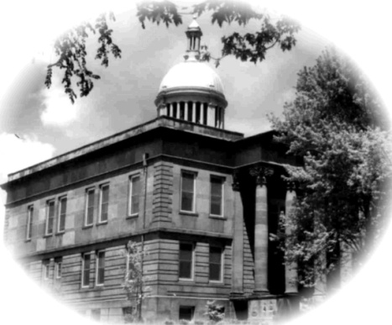
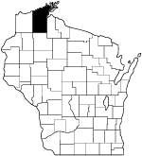

To: Bayfield County Applicant Reference

From: Bayfield County Teen Court

The Bayfield County Teen Court was started in 1998 in response to research which identified that youth defendants respond more effectively to a jury of their peers. The Bayfield County Teen Court provides this representation and develops leadership skills for county youth.

The objectives are:
- Hear first time juvenile cases.
- To create a logical sequence of consequences based in restorative justice.
- To increase their leadership and communication skills while serving the community.

____________________________ has applied to be a panelist for The Bayfield County Teen Court. You have been selected to provide a reference. Your honest opinion of this applicant’s qualifications to represent your community on the Bayfield County Teen Court is appreciated. The information you provide will be handled in a confidential manner and will not be released without your permission.

Please take your time to complete and return the reference by the November 7 deadline to Ian Meeker, Bayfield County Teen Court Advisor, UW-Extension, P.O. 218, Washburn, WI, 54891.

Feel free to provide additional information that goes beyond that addressed by the reference form by attaching a letter. If you have any questions about the position or the reference form, please contact Ian Meeker at (715) 373-6104 ext 249 or via e-mail ian.meeker@ces.uwex.edu

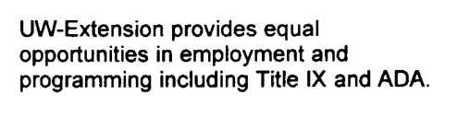
Enclosure: Reference Form

